**Introduction**

With more than 11,000 trains per day, 65,500 km of track, 16 zones, and 7,000 stations, the Indian Railways is the largest railway network in Asia and the second largest in the world. It transports over 20 million people and 7,500 freight services (Nayak et al., 2020).

Derailments still cast doubt on Indian Railways' credibility in spite of modernization efforts. The biggest number of fatalities from derailments in ten years occurred in 2016–2017, when 104 train accidents claimed the lives of 193 passengers, 78 of whom were killed in derailments (Nayak et al., 2020).  
  
While comprehensive derailment analyses are available for Western rail networks, a notable absence of explicit published studies focusing on Indian trains was observed. This deficiency in localized data highlights a significant research gap, emphasizing the necessity for India-specific models in derailment prediction and prevention (Nayak et al., 2020).

**Derailment stats**

Between 2003–2004 and 2015–2016, derailments consistently represented the majority of railway accidents in India. In 2003–2004, 202 out of 325 accidents (84.5 %) were derailments, while in 2015–2016, 65 out of 107 accidents (60.7 %) were attributed to derailments (Ministry of Railways, 2017).  
  
Even in 2016–2017, derailments accounted for 76 of the 99 total railway accidents—nearly 77%indicating that derailment remains the predominant accident type (Ministry of Railways, 2017).  
  
During 2014–2015, out of 161 recorded casualties, approximately 56 % were caused by derailments; in 2015–2016, derailments accounted for a similar 56 % share of total casualties (Ministry of Railways, 2017).

The 2016 Indore–Patna Express derailment resulted in 146 deaths and over 180 injuries, making it one of the deadliest derailments in recent years (Ministry of Railways, 2017).  
  
Although overall accident frequency has declined—from 239 consequential train accidents in 2003–2004 to 85 in 2014–2015—the accident rate per million train-kilometers also fell from 0.28 to 0.10 during the same period, even as traffic volumes increased (Ministry of Railways, 2017).

**Causes**

The primary causes of derailments include rail fracture, weld failure, track defects at curves and turnouts, inadequate worksite protection, and mechanical faults in rolling stock (Ministry of Railways, 2017).

Human error continues to dominate accident causation; approximately 70 % of consequential train accidents during 2014–2016 were attributed to failures by railway staff (Ministry of Railways, 2017).

Incidental or natural causes such as heavy rainfall, falling boulders, and cattle run-overs also contribute to derailments but form a smaller share of total accidents (Ministry of Railways, 2017).

Zone-wise analysis shows the Northern Railway zone reporting the highest number of accidents, followed by the East Central zone—largely due to higher train density and traffic flow in these regions

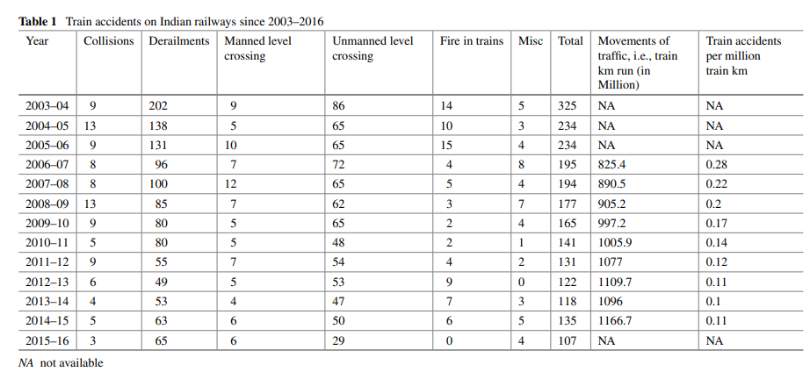

**Recommendation to Reduce the Derailment of Vehicles**

For improving safety, constant upgradation of technology is being incorporated in all spheres of railway operations and infrastructure to increase safety and prevent accidents. These include timely replacement of over-aged assets, adoption of appropriate technologies for upgradation and maintenance of track, elimination of unmanned level crossing, and the use of safety drives. The great emphasis should be given on training of officials and educate staff for observance of safe practices. The inspections should be done at regular intervals to monitor rolling stock, signaling, and interlocking systems.

**Citation :**

Sen, P.K., Bhiwapurkar, M., Harsha, S.P. (2020). Analysis of Causes of Rail Derailment in India and Corrective Measures. In: Gupta, V., Varde, P., Kankar, P., Joshi, N. (eds) Reliability and Risk Assessment in Engineering. Lecture Notes in Mechanical Engineering. Springer, Singapore. https://doi.org/10.1007/978-981-15-3746-2_28